**OBJECTIVES:**

To design, fabricate and measure an equal-split (3-dB) Wilkinson power divider for mobile communication operating at 915 MHz.

**THEORY:**

Power dividers are passive microwave components used for power division or power combining. In power division, an input signal is divided into two (or more) output signals of lesser power, while a power combiner accepts two or more input signals and combines them at an output port. Three-port networks take the form of T-junctions and other power dividers, while four-port networks take the form of directional couplers and hybrids. Power dividers usually provide in-phase output signals with an equal power division ratio (3 dB), but unequal power division ratios are also possible. Directional couplers can be designed for arbitrary power division.

A wide variety power dividers were invented and characterized at the MIT Radiation Laboratory in the 1940s. These included *E*- and *H*-plane waveguide T-junctions, the Bethe hole coupler, multihole directional couplers, the Schwinger coupler, the waveguide magic-T, and various types of couplers using coaxial probes. In the mid-1950s through the 1960s, many of these couplers were reinvented to use stripline or microstrip technology. The increasing use of planar lines also led to the development of new types of couplers and dividers, such as the Wilkinson divider, the branch line hybrid, and the coupled line directional coupler.

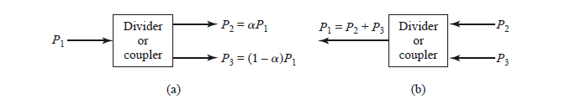

Fig: Power division and combining. (a) Power division. (b) Power combining.

The simplest type of power divider is a *T-junction*, which is a three-port network with two inputs and one output. The scattering matrix of an arbitrary three-port network has nine independent elements.

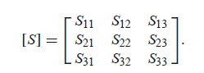

If the device is passive and contains no anisotropic materials, then it must be reciprocal and its scattering matrix will be symmetric (Si j = Sji ). Usually, to avoid power loss, we would like to have a junction that is lossless and matched at all ports. We can easily show, however, that it is impossible to construct such a three-port lossless reciprocal network that is matched at all ports.

If all ports are matched, then Sii = 0, and if the network is reciprocal, the scattering matrix of reduces to

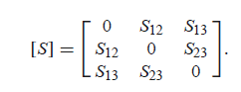

If the network is also lossless, then energy conservation requires that the scattering matrix satisfy the unitary properties which leads to the following conditions:

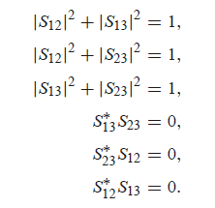

However, this condition will always be inconsistent with one of equations, implying that a three-port network cannot be simultaneously lossless, reciprocal, and matched at all ports. If any one of these three conditions is relaxed, then a physically realizable device is possible.

Any matched lossless three-port network must be nonreciprocal and, thus, a circulator. The scattering matrix of a matched three-port network has the following form:

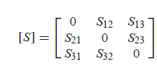

If the network is lossless, [*S*] must be unitary, which implies the following conditions:

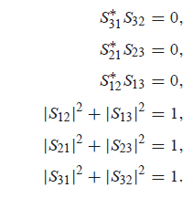

**THE WILKINSON POWER DIVIDER**: The lossless T-junction divider suffers from the disadvantage of not being matched at all ports, and it does not have isolation between output ports. The resistive divider can be matched at all ports, but even though it is not lossless, isolation is still not achieved. We know that a lossy three-port network can be made having all ports matched, with isolation between output ports. The Wilkinson power divider is such a network, with the useful property of appearing lossless when the output ports are matched; that is, only reflected power from the output ports is dissipated.

The Wilkinson power divider can be made with arbitrary power division, but we will first consider the equal-split (3 dB) case. This divider is often made in micro-strip line or strip-line form the corresponding transmission line. We will analyze this circuit by reducing it to two simpler circuits driven by symmetric and anti-symmetric sources at the output ports. This “even-odd” mode analysis technique. It will also be useful for other networks that we will study in later

sections.

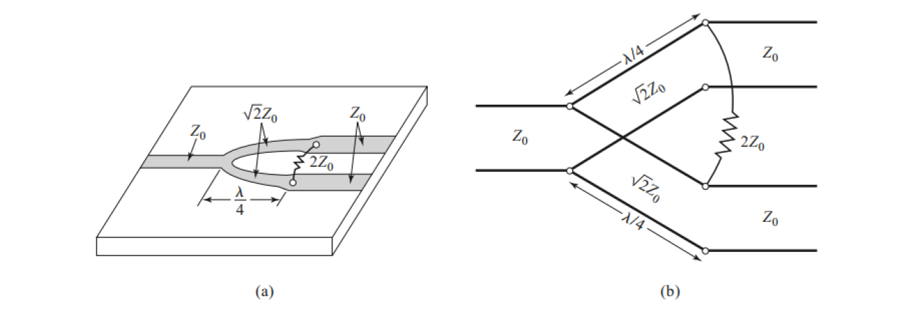

Fig: The Wilkinson power divider (a) An equal-split Wilkinson power divider in microstrip line form (b) Equivalent transmission line circuit.

The Frequency response of equal split Wilkinson power divider should ideally be like shown below:

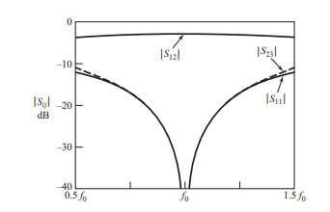

Fig. Frequency Response of equal split Wilkinson power divider

**CIRCUIT DIAGRAM:**

The Wilkinson divider is made up of a transmission line (usually microstrip) that has been divided into a certain number of quarter-wavelength transmission lines. Between each output transmission line and a common junction, resistors are connected. The voltages along each output transmission line are the same magnitude and phase when the outputs are linked to matching loads for an equal split Wilkinson. As a result, there is no voltage drop across the connecting resistors, and no power is dissipated.

Using all the above dimensions, we have designed this circuit of Wilkinson power divider on HFSS software which is shown below.

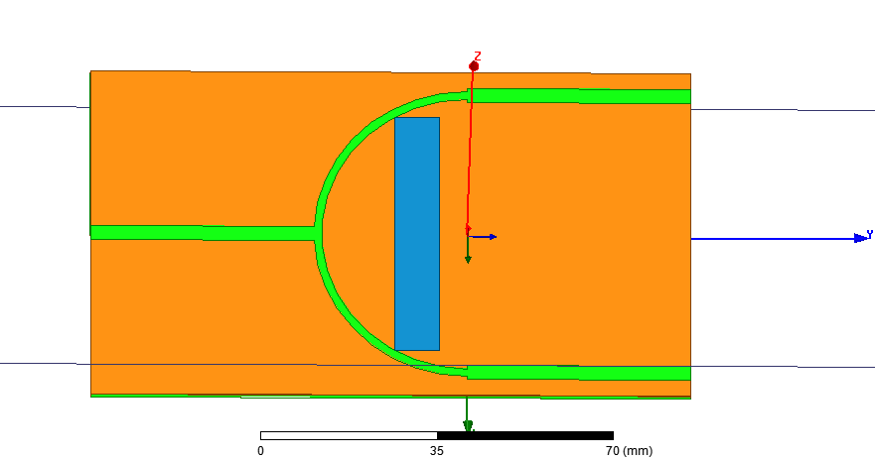

Fig. schematic of Wilkinson power divider

**RESULTS AND PLOTS OBTAINED:**

**1. Plot for S11**

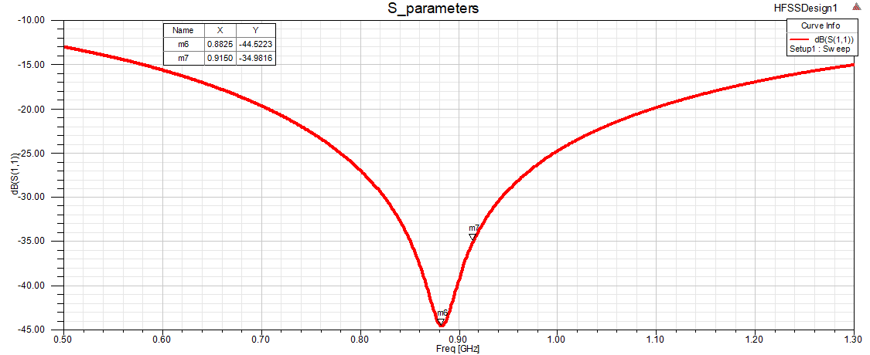

Fig.6(a) Return loss at the input port

**3. Plot of S(2,1)**

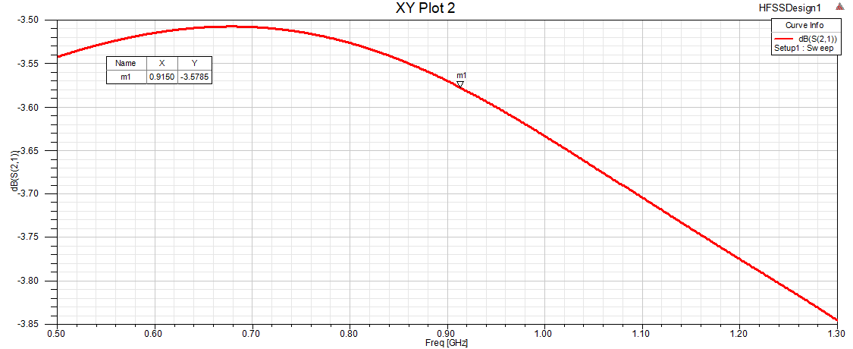

Fig.6(b) Transmission coefficient at port 2 due to input at port 1

**4. Plot of S(2,3)**

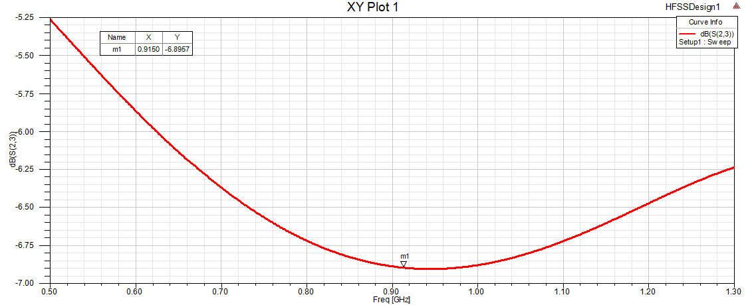

Fig.6(c) Transmission coefficient between port 2 and port 3.

**CONCLUSIONS:**

From Wilkinson power divider I have concluded that there is almost equal power division at the all output ports(i.e port 2 and port3) and good isolation between the output ports is obtained at the required frequency. Isolation between output ports can be achieved by adjusting the gap width of quarter wave sections. Wilkinson power dividers are extremely durable devices, and multiple designs can produce equivalent results, especially when built with simple microstrip manufacturing processes and used at appropriate frequencies. Straight Quarter wave sections can be employed for the same performance with less risk of degradation and a more compact and narrower design.